May Pocket Scope Newsletter

Posted on May 21, 2019 by [mhernandez](http://sites.ieee.org/houston/author/mhernandez/) IEEE websites place cookies on your device to give you the best user experience. By using our websites, you agree to the placement of these cookies. To learn more, read our [Privacy Policy.](https://www.ieee.org/about/help/security_privacy.html)



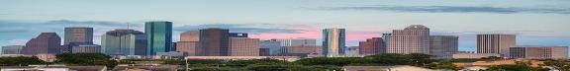

May 2019 Vol. 68 Issue 2

THE POCKET SCOPE

[IEEE Houston Section](http://sites.ieee.org/houston/) Monthly Newsletter

**Greetings Houston Section!**

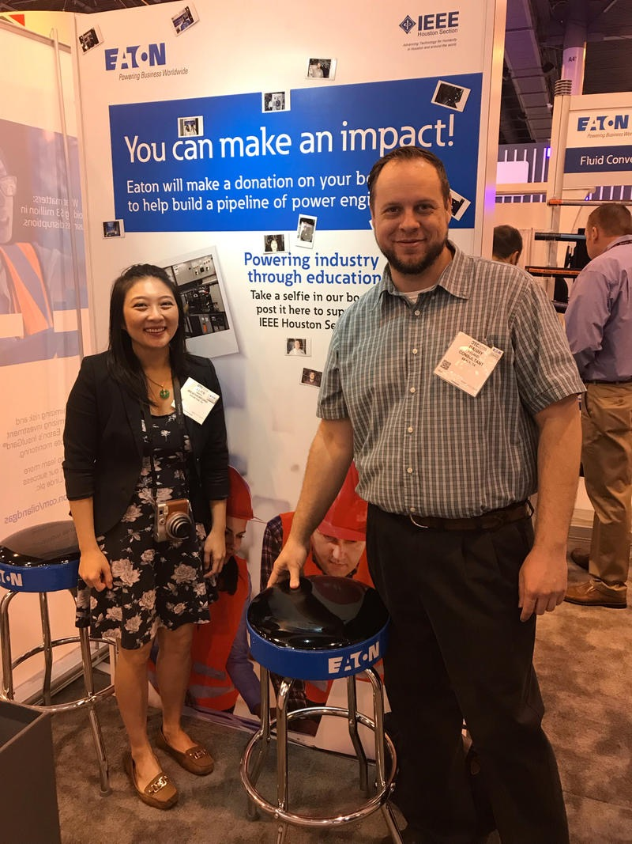

**Alice Wang and Danny Feland at OTC 2019**

[Houston Section of IEEE](http://sites.ieee.org/houston/) highlights from May includes the IEEE and Eaton Booth at The Offshore Technology Conference ([OTC](http://sites.ieee.org/houston/event/2019-offshore-technical-conference-otc/)). The Houston section Ocean Engineering Society ([OES](http://ieeeoes.org/)) had a booth at the Society of Petroleum Engineers electric submersible pumps (ESP) symposium, which was held in the Woodlands. Our Rice Student Branch members won a circuit design contest and will be representing Regions 1-7 (USA and Canada) at the International Symposium of the [Circuits and System Society](https://ieee-cas.org/), later this month. I wanted to recognize Jacobs Engineering, who was awarded the 2018 Region 5 [Large Company Award](http://sites.ieee.org/houston/jacobs-engineering-receives-ieee-region-5-outstanding-large-company-award/), and the Rice University Student branch, who won the Region 5 2018 Student Branch award. Congratulations! Earlier, this year, the IEEE Houston Section awarded a scholarship to Texas A&M biomedical student [Jeremy Feland](http://sites.ieee.org/houston/jeremy-feland-wins-2018-houston-section-ieee-scholarship/). On May 23, at HESS, we will have an excellent presentation about [NASA’s current mission](http://sites.ieee.org/houston/event/nasa-mission/).

It is a great time to be involved with IEEE. Please join us on the 23rd at [HESS](https://www.hessclub.com/), the general meeting starts at 6:30. It will be a great networking and learning opportunity.

Warmest regards,

**Alice Wang**

**Section Chair - IEEE Houston Section**

[Rice Design Team Finalists at Regional Circuits and Systems Design Contest](http://sites.ieee.org/houston/rice-design-team-finalists-at-regional-circuits-and-systems-design-contest/)



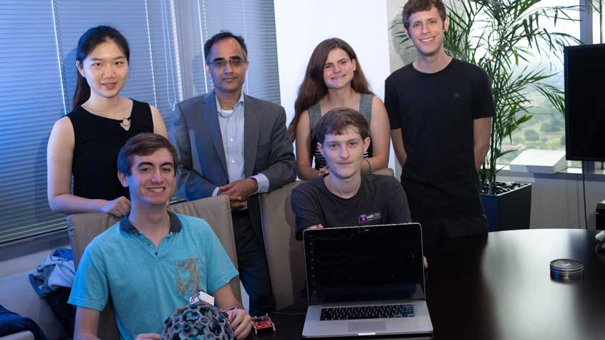

[Dr. Joseph Cavallaro](mailto:cavallar@rice.edu), the Houston area [Circuits and Systems Society](https://ieee-cas.org/) Chair and [Rice University Student Branch](http://ieee.rice.edu/) Counselor, reported that the Axon Mobile Senior Design Team has been selected as a finalist in the IEEE Circuits and Systems student design contest. The Axon Mobile team members - Aidan Curtis, Sophia D'Amico, Andres Gomez, Benjamin Klimko and Irene Zhang, are developing an instrument to gather signals from a seizure patient's brain and send them wirelessly to a computer. This design is superior to the current method, which involves a lot of wires and cables, tethering a patient to a bunch of machines, rather than letting them be free to move about, and have less stress. The Axon team, which is composed of Rice IEEE Student Branch members, will be traveling to Sapporo Japan to represent Regions 1-7 (USA and Canada) and compete against teams from the rest of the world at the flagship [International Symposium of the Circuits and Systems Society](https://ieee-cas.org/international-symposium-circuits-and-systems-iscas) (ISCAS) at the end of May. For more details on this brilliant project and the team, click [here](https://www.ece.rice.edu/news/these-students-hope-cut-ties-bind-seizure-sufferers). To learn more about the Circuits and Systems design competition click [here](https://ieee-cas.org/2018-2019-cass-student-design-competition-finalists) and [here](https://ieee-cas.org/2018-2019-cass-student-design-competition).  

The Houston Section of IEEE extends the heartiest congratulations Dr. Cavallaro, the Rice Student Branch, and especially the members of the Axon Mobile Design Team. Job well done! Best of Luck at ISCAS in Sapporo. We are all very proud of you.

[Technology Spotlight – Chris Sanderson](https://spectrum.ieee.org/the-institute/ieee-member-news/ten-on-tech-spotlight-on-christopher-sanderson)

Our own IEEE [Houston Section](http://sites.ieee.org/houston/) Vice Chairman and South Area Chair for [Region 5](http://ieeer5.org/) Christopher Sanderson has been featured in an article in the [IEEE Spectrum](https://spectrum.ieee.org/)! [Ten on Tech: Spotlight on Christopher Sanderson](https://spectrum.ieee.org/the-institute/ieee-member-news/ten-on-tech-spotlight-on-christopher-sanderson) is an inspiring summary of one of our hardest working IEEE Houston Section volunteers. It is a great read for any IEEE member that gives great insight into Christopher’s genuine good nature and drive.

IEEE Houston Consultants Network Meeting May 30th Estimating Engineering Projects

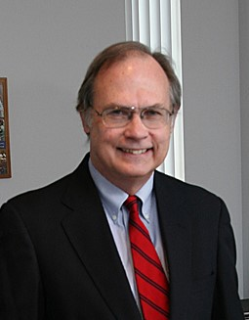

**John Martin, PE President, Martin Company**

Estimating Engineering Projects

May 30th (Wednesday) 5:30 pm General Meeting

Clayton Library Center at 5300 Caroline St.

Free parking! The meeting will be held in the Carriage House. IEEE Houston Consultant Network members, IEEE Members, interested parties, students and guests are all welcome! Please RSVP to [**tgcooper@sbcglobal.net.**](mailto:tgcooper@sbcglobal.net)

Agenda

5:30 PM – Networking

5:45 PM – Brief announcements and introduction of speaker 6:00 PM – Presentation followed by Q and A

7:30 PM – Adjourn

**Presentation:**

Estimation is an art; accurate estimation is a science, critical to project success. Converting abstract requirements into tangible measurable time-cost units is helpful to align customers’ expectations with technical solutions. Martin Company estimates the budget and schedule for our electronics hardware/software engineering projects based on agile techniques. John will describe the challenges and opportunities with estimating engineering projects, some interesting solutions that are improving project estimates, and conclusions on the current state of project estimating.

**Speaker:**

John Martin is electronics engineer and has served as president of Martin Company in Rosenberg, Texas since 1980. Martin Company is an ISO-9001 certified electronics engineering and manufacturing company that in 38 years has completed over 3100 engineering and manufacturing projects. We plan projects, do product research and development, draw schematics, layout pc boards, write software/firmware, assemble and test prototypes, and document designs for production. We design and manufacture both low and high temperature electronics. John has also been with Analog Devices, Western Geophysical and H.M. Wilson Company. He earned his BSEE at the University of Houston.

[IEEE HOU Sec. Student Branch Leadership Training](http://sites.ieee.org/houston/ieee-hou-sec-student-branch-leadership-training/)

It’s been reported that 83% of companies express that it’s important to develop leaders at all levels. In response to this, on May 5, 2019, Houston Section Secretary, [Moriah Hargrove Anders](mailto:moriah.s.hargrove.anders@ieee.org), led a group of about fifteen student IEEE leaders through the [Houston Section’](http://sites.ieee.org/houston)s first annual **Student Branch Leadership Training**.

[](http://sites.ieee.org/houston/files/2019/03/logo-PVAMU.png)[](http://sites.ieee.org/houston/files/2016/02/TXAMU.png)[](http://sites.ieee.org/houston/files/2019/03/logo-UH.png)Representatives from [Texas A&M University](https://ieee-tamu.org/), [University of Houston](http://ieee.ece.uh.edu/), and Prairie View A&M University were all in attendance. [Christopher Sanderson](mailto:christopher.b.sanderson@ieee.org), Houston Section Vice-Chair and [Region 5 South Area](http://ieeer5.org/areas/south-area/) Chair, also supported the training and provided key insights during the presentation. The training was hosted in the Prairie View A&M Library and lasted about 2.5 hours.

Lots of good content was covered and included [Region 5](http://ieeer5.org/) organizational charts, an explanation of student branch content, membership benefits, marketing tips, where to find additional officer training, and so on. Funding sources and funding advice was also provided by the Houston Section to the Student Branches.

**Key Takeaways:**

1. Have your Chair or Student Branch Counselor order the **MD kit**: <https://mga.ieee.org/membership-development/membership-development-kits> Only one order per student branch per year
2. Update your officer reporting in **vTools**. <https://officers.vtools.ieee.org/>
3. Submit your **Student Branch plan** <https://sbr.vtools.ieee.org/> & develop a calendar of events for the whole year. Submit appropriate events into vTools events.  Advertise the whole calendar of events during your recruitment events so that members can block off their calendars.

If you are a student leader and would like a copy of the material shared during the presentation that include these takeaways and other good information, please reach out to the Houston Section Secretary or Vice-Chair to obtain a copy.

***Huge thank you to Dr. Cui and Prairie View A&M for hosting the training on behalf of IEEE.  The Houston Section appreciates the support of PVAMU for our initiatives.***

IEEE Sponsored Conferences Coming to Houston

There are 2 interesting conferences that will be held in Houston, over the next few months, which will be great opportunities to interact with other IEEE and industry leaders. July 15-17 the [2019 Carbon Management Technology Conference](http://bmsmail2.ieee.org:80/ctd/lu?RID=1-66V4P9G&CON=1-28P-1258&PRO=&AID=&OID=1-66T2RSK&CID=1-66T2RSD&COID=1-66T2RXQ&T=http%3a%2f%2ffscarbonmanagement.org%2fcmtc%2f2019&Z=80fe55975da26c6fa44bd2ffff01dad&TN=fscarbonmanagement.org%2fcmtc%2f2019&RT=Clicked+On+URL) will be held, downtown in the Magnolia Hotel.

On 19-21 September 2019 the International Symposium on Measurement and Control in Robotics ISMCR 2019 will be held in Houston. For conference Details: www.ISMCR.org

Volunteer Needed: IEEE Houston Teacher In Service Program

## May 21 @ 8:00 am - 5:00 pm CDT

* [**« Ambient and Quantum Backscatter Communications**](http://sites.ieee.org/houston/event/ambient-and-quantum-backscatter-communications/)
* [**EXCOM »**](http://sites.ieee.org/houston/event/excom-4/)

Volunteers needed!

There will be a session of Teacher In-Service Program (TISP) session taking place at:

Harris County Department of Education, 6300 Irvington Blvd, Houston, TX 77022.

Note: The address is a high-rise red brick building located near North Loop 610 and Irvington, outside the loop.  The classroom for this session is in a single-story building across the side street from the building listed above in a parking lot.  The classroom building on the backside of that parking lot.

The session starts at 8:30 a.m. and should last for about 7 hours.  There will be teachers from many school districts around Harris County, both elementary and secondary.

 If you are interested to attend, contact Freddie Wong at [freddiewong@ieee.org](mailto:freddiewong@ieee.org) .

Location:  
Harris County Department of Education  
6300 Irvington Blvd  
HOUSTON, Texas  
77022

[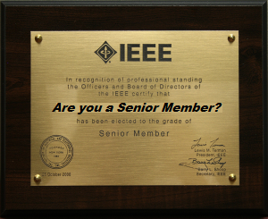](http://sites.ieee.org/houston/about-ieee/ieee-senior-membership/)[Spring Senior Membership Drive](http://sites.ieee.org/houston/about-ieee/ieee-senior-membership/) Continues

If you’ve been an IEEE member, for about 10 years, maybe you should consider becoming a [Senior Member](http://sites.ieee.org/houston/about-ieee/ieee-senior-membership/). Being a Senior Member, has many benefits, is easy to apply for, helps the Houston Section, and is free to do. [Check out this article:](http://sites.ieee.org/houston/apply-for-ieee-senior-membership/)

[Houston Section Events for May 2019](http://sites.ieee.org/houston/events/2019-05/)

Check out the Houston Section Events page for all the latest information taking place in the Greater Houston Metro Area. Looking forward to seeing you at an event soon.

*The Pocket Scope* is the monthly newsletter of the [Houston Section](http://sites.ieee.org/Houston) of the [Institute of Electrical and Electronic Engineers, Inc.](http://www.ieee.org/) New issues are published around the 15th of each month. The deadline for inclusion of material is the 10th of the month. Send submissions, comments, or questions to [Dr. Payal Majumdar](mailto:payalmajumdar.udsc@ieee.org) or [Vincent Palughi](mailto:vpalughi@ieee.org).Accept & Close

* [Home](http://sites.ieee.org/houston)
* [Contact IEEE Houston Section](http://sites.ieee.org/houston/contact-us/)
* [Accessibility](http://www.ieee.org/accessibility_statement.html)
* [Privacy & Opting Out of Cookies](http://www.ieee.org/security_privacy.html)
* [Nondiscrimination Policy](http://www.ieee.org/about/corporate/governance/p9-26.html)

IEEE Houston Section  
Houston Section  
© Copyright 2019 IEEE - All rights reserved. Use of this Web site signifies your agreement to the [IEEE Terms and Conditions](http://www.ieee.org/site_terms_conditions.html).  
A not-for-profit organization, IEEE is the world's largest technical professional organization dedicated to advancing technology for the benefit of humanity.

|  |  |
| --- | --- |
|  |  |

|  |  |
| --- | --- |
|  |  |