 | IEEE  Power & Energy Society & Power Electronics Society - WA Chapter, and Sustainable Energy Now (SEN) | 

Operating the Electricity Grid with Low Inertia
29th April 2019, 17:30 - 19:00  Lecture Theatre, Central Park Building  152 St Georges Terrace, Perth  (please see below for detailed directions)  Julius Susanto  Senior Power System Security Engineer  Australian Energy Market Operator (AEMO), Perth, Western Australia. | 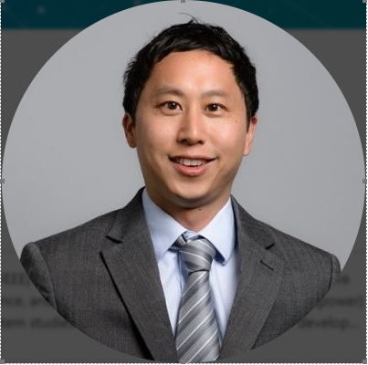

You are invited to the joint IEEE Power & Energy Society (PES) and Sustainable Energy Now (SEN) event, where Julius Susanto will be presenting on “Operating the Electricity Grid with Low Inertia.”

Registration is essential - please contact: Michelle Kenworthy-Groen; Michelle.Kenworthy-Groen@aemo.com.au , (T) 08 9469 9977
Event fee: no charge

About the Speaker:
Julius Susanto is a Power Systems Specialist and a Chartered Electrical Engineer (CPEng MIEAust) with over 17 years of extensive practical and modelling experience and postgraduate qualifications in electrical (power) engineering and economics.
His area of expertise extends to power system studies and analysis, utility-scale solar PV development and grid integration, hybrid microgrid design, software development for electrical engineering, techno-economic and regulatory analysis of electricity supply systems. He is currently completing his PhD in Stability of Microgrids and Weak Networks at Murdoch University. He graduated from Curtin University in 2013 in Master of Science (MSc), Electrical Utility Engineering; and completed his Bachelor of Engineering, (Electrical) with first class honour at Curtin University in 2001. Julius also holds a Graduate Diploma in Business Economics from the University of Western Australia. He is a member of IEEE PES and Sustainable Energy Now (SEN).

Directions:
The link below will give you a virtual tour of the Central Park Conference Facility. Entry is either via Ground level then stairs, which lead up to the first-floor foyer, and in turn the theatrette and other board/seminar rooms; or if required there is also elevator/disabled access to the first floor from an alternative entry approx. 20m from the main entrance. The main entrance to the Conference facilities is off the arcade/courtyard located behind the main Central Park office tower. This area can be accessed from St. Georges Tce, Hay or William Streets. Several public parking areas are within easy walking distance.

http://www.central-park.com.au/Core/Content/ConferenceCentre/Content3407.aspx

