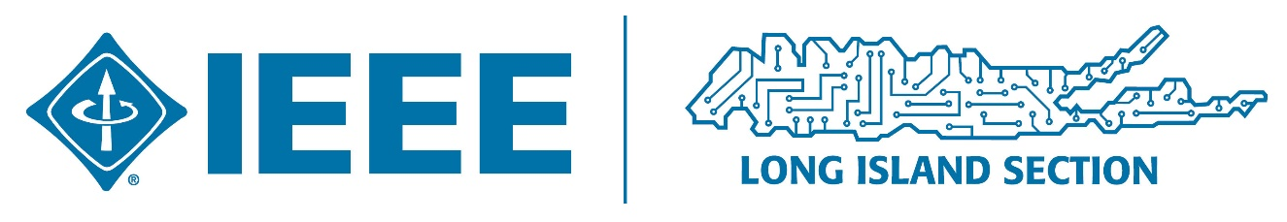

November 2020 Newsletter

Welcome to the IEEE Long Island Section November 2020 e-Newsletter.
We will be publishing this e-newsletter periodically to try to keep our membership informed on a wide variety of technical topics. If you have any comments and/or suggestions, please reply back to us. Thanks.
In these unusual times it would be nice if we could all indulge in some learning as we deal with reduced or missing work hours.
Below are some links to free Webinars on a very wide range of highly interesting topics. Enjoy!
We are happy to report that the LI section had a (virtual) 1010 day last October 10th. Thanks to the efforts of Barbara Porter and Lonnie Chu, the Section hosted a very successful event. The two guest speakers for the event, Bart Romeny and Peter Scott were online from the Netherlands and California, demonstrating that geography is no barrier to these events. Between the two speaker sessions, Marj Issapour and Ron Pirich hosted an insightful panel discussion featuring local tech professionals and Section members. The turnout for the meeting was encouraging, with about 30 attendees logged in, even though October 10 was a Saturday. Planning for next year’s event will start soon; anyone interested in helping put it together is welcome to contact Arnie Stillman for further information. There is no theme for next year’s 1010 Day yet, and it is on a Sunday. Organizing it will be a challenge, but it will be rewarding when it comes off as successfully as this year’s
UPCOMING & ONGOING EVENTS
- These free events from the Cold Spring Harbor Labs include some targeted at teen-agers as well as many aimed at adults on a wide range of fascinating topics: https://dnalc.cshl.edu/resources/dnalc-live/
- Self-explanatory but a bit frightening: https://nationalinterest.org/blog/buzz/why-us-air-forces-bombers-and-stealth-fighters-need-hardened-gps-169375
- Employment Opportunities. Thanks again to Charlie Pleckaitis: https://ieee.li/committees/employment-assistance-committee/ “Grow with Google” aims to help by providing free training, tools, and expertise. GO TO https://grow.google Find & lookup: JOB SEEKERS and STUDENTS; VIRTUAL WORKSHOPS under Start Learning. Find your next job on Google Search; Create a Resume in Google Docs; Includes Resume Styles like Engineering Style; Find remote Job Opportunities; Explore Work-From-Home-Jobs; Build Your Skills; Learn To Code Through Quick Lessons on Your Phone; Enhance Your Resume with a New Certificate; Learn Basic Skills From Anywhere; Grow with Google Partner Signup; Etc.
- Some really interesting stuff from the National Academies of Sciences, Engineering, and Medicine: https://www.nationalacademies.org/home
- A different slant on GPS systems and their potential vulnerabilities: https://www.militaryaerospace.com/sensors/article/14184710/pnt-gps-security
- An unexpected article on battery operated rickshaws in Bangladesh partially sponsored by IEEE: https://sight.ieee.org/projects/carg-sight/
- Very current article comparing artificial intelligence and human intelligence: https://towardsdatascience.com/ai-insights-for-human-intelligence-5ce4d10d431
- Flexible, Wearable Sensors Detect Workers’ Fatiguehttps://spectrum.ieee.org/tech-talk/biomedical/devices/flexible-wearable-sensors-detect-workers-fatigue A potential new technology with both positive and privacy infringement concerns
- Article on Nanomotors from the IEEE Spectrum Magazine, “Plasmonic Nanomotors Move in New Directions”: https://spectrum.ieee.org/nanoclast/semiconductors/nanotechnology/novel-technique-moves-nanomotors-with-a-high-level-of-control
Many thanks for some of these items to Bill Wilkes and the Google group he moderates: Long Island Engineers Club (long-island-engineers-club@googlegroups.com)

Contributors: Arnie Stillman, Lou D'Onofrio, Carl Meshenberg, Howard Edelman
Editor: David C Pinkowitz ( david.pinkowitz@ieee.org)

