

**Metro LA Signal Processing**

**Chair:** Eremita Miranda, MBA, P.E.

**Vice Chair:** David D. Morabito, JPL

**Secretary****:** Jennifer Harlow, Young & Co

**Treasurer:** Ray Harlow, P.E., Young & Co

**Liaison with Caltech Student Branch**

**Hope Arnett, Caltech Chapter President**

**Chapter Advisor:** Alfred Paiz, JPL

**Webmaster:** Chris Harlow, Young & Co

**Arrangements Committee Chair** Gary Palit, Kewo Corp, Director of Operations

**Founder:** Eremita Miranda, MBA. P.E.

**Metro LA Section Executive Officers**

**Section Chair:** Tom Walker, CEO Virtual Sphere

**Section Vice Chair & Past Chair:** Eremita Miranda, MBA. P.E.

**Section Treasurer:** Ray Harlow, P.E., Young & Co

**Section Secretary:** Jennifer Harlow, Young & Co

**Membership Elevation Chair:** Dr. Huang, JPL

**Member Elevation Application Reviewer:** Andrew Tomat

**Note:** The minutes of the meeting will be sent to all attendees

**1-13-24 METRO LA SECTION VIRTUAL MEETINTG WITH SIGNAL PROCESSING SOCIETY & ALL METRO SPONSORED UNITS FOLLOWED BY A DRIVE THRU GRAB & GO AT STONE FIRE GRILL.**

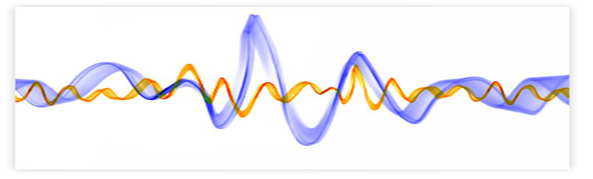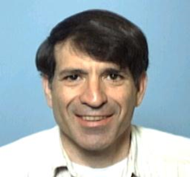

**Topic**: **Signal Processing Applications in Spacecraft-to-Ground Links**

**Presenter: David D. Morabito, JPL**

**About the Speaker:** David D. Morabito has worked at Caltech’s Jet Propulsion Laboratory, Pasadena, CA, on numerous engineering and scientific research projects since 1973. Among the areas he has worked on are spacecraft navigation, Very Long Baseline Interferometry (VLBI), Radio Science experiments on the Voyager 2, Ulysses, and Galileo spacecraft, performance characterization of beam-waveguide antennas, media propagation effects on spacecraft telecommunication links, and telecommunications systems design for proposed future space mi.

His most recent project is studying the use of Ka-band (32 GHz) for deep-space navigation aPEnd for spacecraft telecommunications, with a focus on media effects on signal propagation.

He has numerous publications in several professional journals, and conference proceedings. He is a member of the IEEE, and International Astronomical Union. He was a past member of the American Astronomical Society and American Geophysical Union. He has also participated in International Telecommunications Union (ITU-R) Working Party activities with regards to signal propagation.

**Reservation:** Please RSVP with your IEEE membership # to: Eremita Miranda ([eremitam@outlookcom](mailto:eremitam@outlookcom)) & Jennifer Harlow ([Jennifer.Harlow@youngco.com](mailto:Jennifer.Harlow@youngco.com)). **You may bring your spouse/companion. All we need is his/her name & email**.