 ** **

**METROPOLITAN LOS ANGELES SECTION JOINT MEETING ON 09-23-23 WITH THE METRO LA PHOTONICS CHAPTER AND ALL SECTION SPONSORED UNITS WITCH ARE:**

**CSC, COMMUNICATIONS, EMBS, GRSS, IAS, MTT-S, PHOTONICS, RAS, PES, SIGNAL PROCESSING, YPs, CALTECH, CSULA, USC**.

The virtual meeting will start at 11:00 a.m. PST and will end by noon, followed by a Drive Thru IEEEGrabandGo lunch at [Stonefire Grill](https://stonefiregrill.com/) in Pasadena C.A**.** [**hosted by the section**](https://r6.ieee.org/metrola/).

Please ORDER YOUR DRIVE THRU GRAB AND GO as soon as you register for the Virtual meeting and no later than 9-14-23 5:00 p.m. PST

PLEASE SCROLL DOWN FOR INSTRUCTIONS ON HOW TO REGISTER FOR THE VIRTUAL MEETING AND THE DRIVE THRU GRAB AND GO AT STONE FIRE GRILL.

SCROLL DOWN FURTHER TO SEE THE ADDRESS OF THE STONE FIREGRILL

Please follow government requirements [COVID-19 | USAGov](https://www.usa.gov/coronavirus). The attendees will not enter the building except for biological needs. As soon as the attendees arrive at [Stonefire Grill](https://stonefiregrill.com/) they will Grab their lunches and will go home.

They must respond to the invitation to the virtual meeting by sending a request with their membership numbers to: Jennifer Harlow (Jennifer Harlow [Jennifer.Harlow@youngco.com](mailto:Jennifer.Harlow@youngco.com)) & Eremita Miranda ([eremitam@outlook.com).](mailto:eremitam@outlook.com).) Spouses/Companions are invited. All that is needed is their names and emails to be included in the reservation list.

As soon as the attendees complete their registrations, they must call [Stonefire Grill](https://stonefiregrill.com/) catering office at **(888) 649-5783** to give their names, phone numbers and their lunch preferences per the menu shown below. They must indicate that they are ordering for *IEEE Grab and Go*.

**The cutoff date to call the restaurant and order the *IEEE Grab and Go* at is 9-21-23 at 5:00 p.m. PST Ordering after that, will be at the discretion of the restaurant.**

[**Stonefire Grill**](https://stonefiregrill.com/) **is a very busy restaurant. Last minute ordering puts a lot of pressure on the restaurant staff. The Drive Thru start at noon after the virtual meeting and will end by 3:00 p.m.** For questions about this meeting please send an email to the Event Chair: [eremitam@outlook.com](mailto:eremitamiranda@outlook.com)

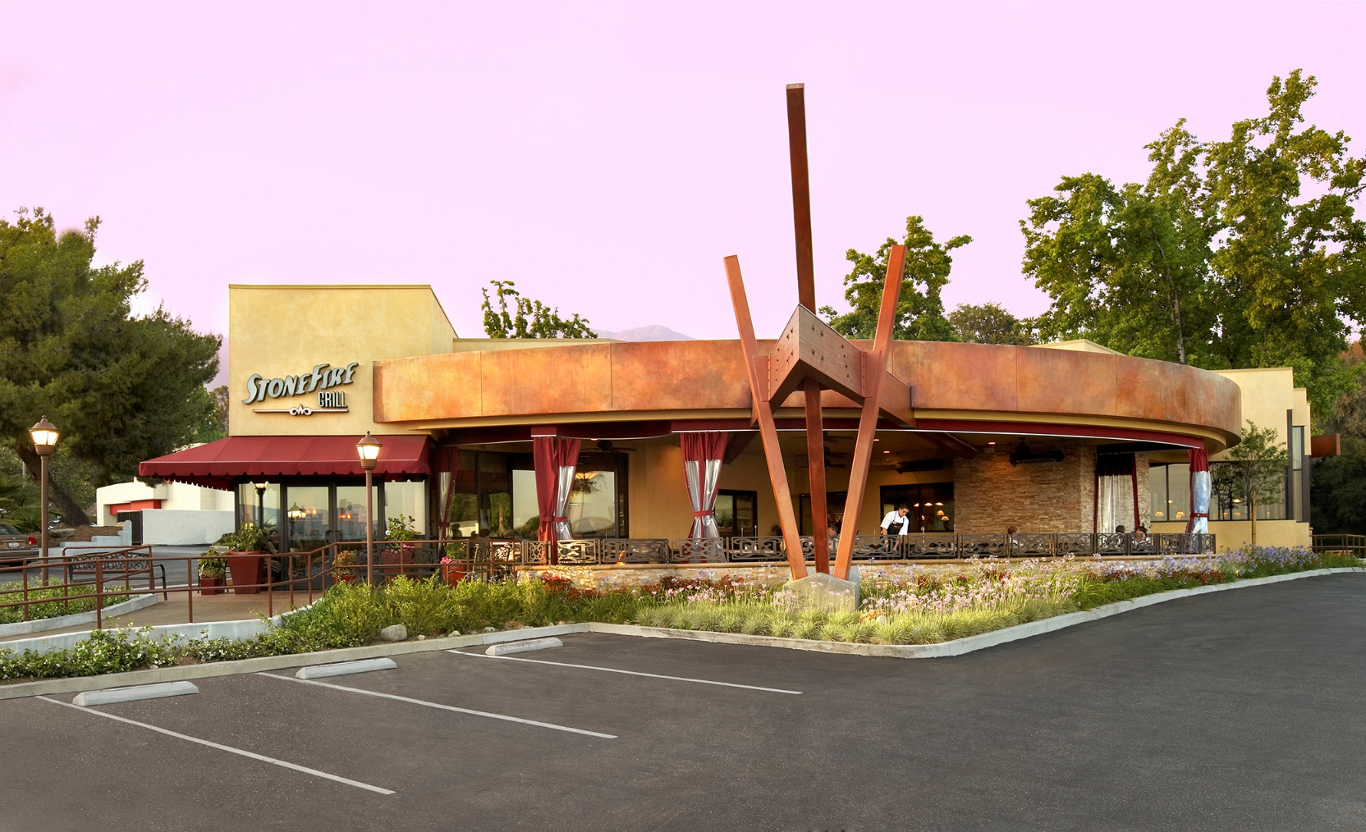 [**Stonefire Grill**](https://stonefiregrill.com/)**,** [**473 N Rosemead Blvd, Pasadena, CA 91107**](https://www.google.com/maps/place/473+N+Rosemead+Blvd,+Pasadena,+CA+91107/@34.1541607,-118.080481,17z/data=!3m1!4b1!4m5!3m4!1s0x80c2dc9cbebe6565:0x9c8aa0e5904f89fe!8m2!3d34.1541607!4d-118.0782923)**.**

**The cutoff date to call the restaurant and order the *IEEE Grab and Go* at Stonefire Grill is 06-22-23. After that, it will be up to the restaurant**