August Pocket Scope Newsletter

Posted on August 27, 2019 by [vpalughi](mailto:vpalughi@ieee.org)IEEE websites place cookies on your device to give you the best user experience. By using our websites, you agree to the placement of these cookies. To learn more, read our [Privacy Policy.](https://www.ieee.org/about/help/security_privacy.html)



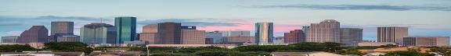

August 2019 Vol. 68 Issue 4

THE POCKET SCOPE

[IEEE Houston Section](https://r5.ieee.org/houston/) Monthly Newsletter

**Greetings Houston Section!**

[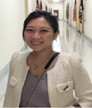](http://www.google.com/url?sa=i&rct=j&q=&esrc=s&source=images&cd=&ved=2ahUKEwjW_ZKjgZLjAhWRcc0KHeRrBJ4QjRx6BAgBEAU&url=http%3A%2F%2Fsites.ieee.org%2Fhouston%2Fwelcome-excom-leadership-2018%2Fpic-alice-wang%2F&psig=AOvVaw02d8NlvfUA_xITY5jHBENz&ust=1562011675365852)

**Alice Wang Section Chair IEEE Houston Section**

Usually, during the summer, the IEEE Houston Section takes things a little slower, but not this summer! Our members and enthusiastic volunteers have been quite busy engaging and serving our 3600+ strong local section! We were honored to celebrate the awarding of two Region 5 [Stepping Stone awards](http://ieeer5.org/awards/stepping-stone-award/) at the NASA/ Johnson Space Center on July 27th. Check out this YouTube video, produced by our own [Fabian Pineda](mailto:fabianpineda@ieee.org) about the awards ceremony [here](https://www.youtube.com/watch?v=WBk4L6GTbwU). The Houston section website has a new URL: <https://r5.ieee.org/houston/>, please update or add us to your favorites! The old website, is still up, but will no longer be updated. On July 24th the Houston section [IEEE Control Systems Society](http://ieeecss.org/) held a meeting at Chevron’s downtown office. On Friday, July 26, 2019 [IEEE TryEngineering Summer Institute South](https://tryengineering.org/student/ieee-tryengineering-summer-institute-texas-am-university/) location at [Texas A&M University](http://www.tamu.edu/) hosted over 300 students from around the world. At the TryEngineering Summer Institute (TESI) program, 8th – 12th grade school students explored various engineering fields, such as Electronics, Electrical, Civil, Mechanical, and Aerospace.

We are accepting applications for the [Houston Section Scholarship](https://r5.ieee.org/houston/about-ieee/ieee-houston-section-scholarships/). Applications are due by August 31st. Have you received your IEEE election ballot, or the several emails about the election? IEEE is a 422K+ strong international organization, with 10K+ employees, and annual revenues of almost $500M, led by members and volunteers. These elections are important but typically less than 10% of the membership votes. Please take the time, to review the [candidates bios](https://www.ieee.org/about/corporate/election/candidates.html) and [cast](https://services10.ieee.org/idp/startSSO.ping?PartnerSpId=AnnualElection) your important ballot, before the October 1st deadline! Finally, please consider attending the International Symposium on Measurement and Control in Robotics [ISMCR 2019](http://WWW.ISMCR.ORG) which will be held at the [University of Houston-Clear Lake](https://www.uhcl.edu/) on 19-21 September. Have a great summer and we will see you at our next regular meeting at [the HESS Club](https://www.hessclub.com/) on September 26th. Mr. Chris Macha and Mr. Rick Zamarripa, the owners of the [Electronics Parts Outlet (EPO)](https://epohouston.com/) will present an exciting session about the local electronic hobbyist scene and their outstanding community outreach with their free educational electronics and robotics workshops.

Warmest regards,

**Alice Wang**

**Section Chair - IEEE Houston Section**

[Two NASA Teams Win IEEE Stepping Stone Awards](https://r5.ieee.org/houston/ieee-joins-in-50th-anniversary-of-apollo-11-landing-celebration-by-presenting-ieee-r5-stepping-stone-awards/)

IEEE Joins in 50th Anniversary of Apollo 11 Landing Celebration

by [**Vincent Palughi**](mailto:vpalughi@ieee.org)



[](https://www.ieee.org/)

On July 27th IEEE Region 5 dedicated Stepping Stone awards to two NASA teams that have been crucial to The National Aeronautical Space Administration ([NASA](https://www.nasa.gov/)) programs. One award was presented for the creation of the Analytic Ephemeris Generator (AEG), which provided the rapid planning and real-time orbit predictor for early space programs. Subsequent advancement of the AEG is still used in manned space mission orbit predictions. The AEG plaque will be seen by all Space Center Houston visitors going for the Mission Control visit.

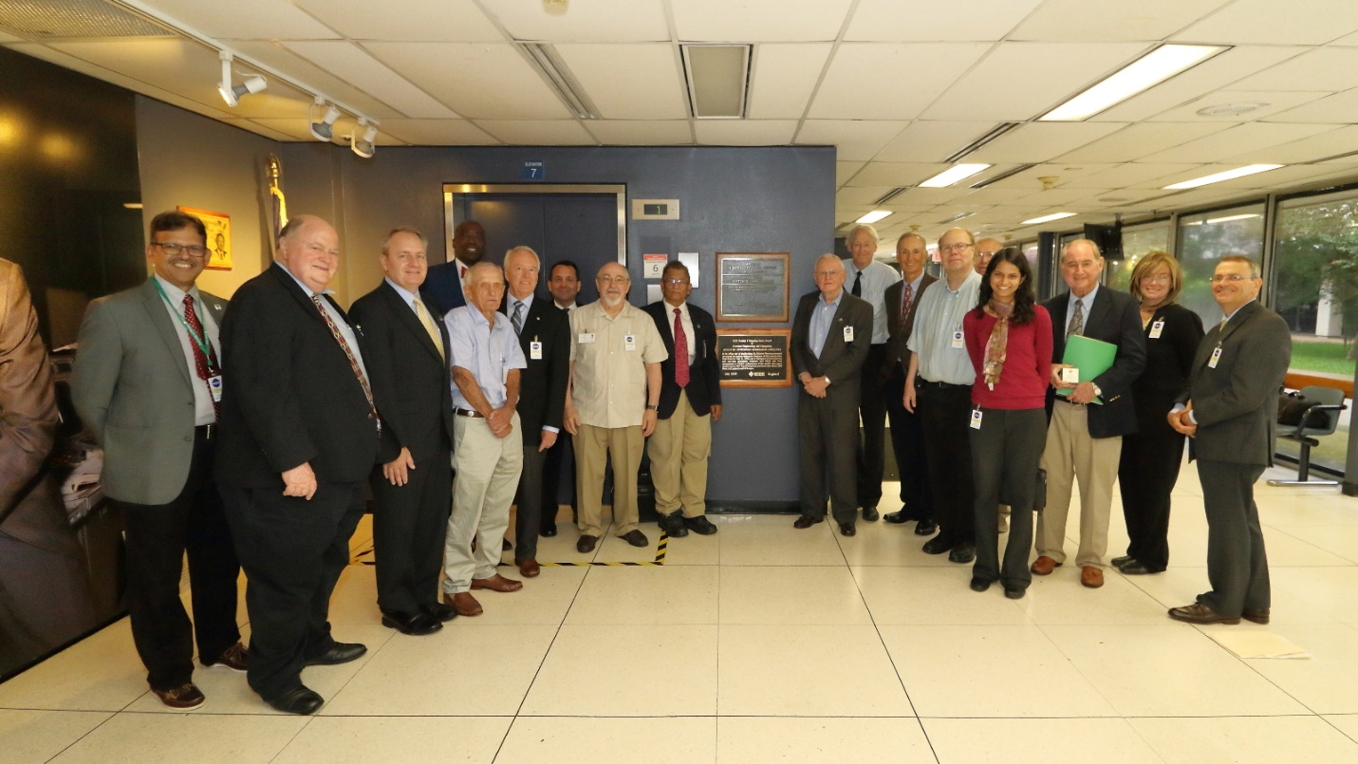

**AEG Plaque unveiling in JSC Mission Control Lobby - Dr. Ishaq Unwala, Arland Actkinson, Bruce Manners, Chris Sanderson, James Jefferies, Robert Shapiro, Dr. Thomas Harman, Dr. Zafar Taqvi, Scott Atkinson, Dr. Sabia Abidi, Michelle Krueger, Vincent Palughi. AEG achievers - Ken Young, Merritt Jones, Hal Beck, Bob Regalbrugge, Roger Reini and Bill Bridges.**

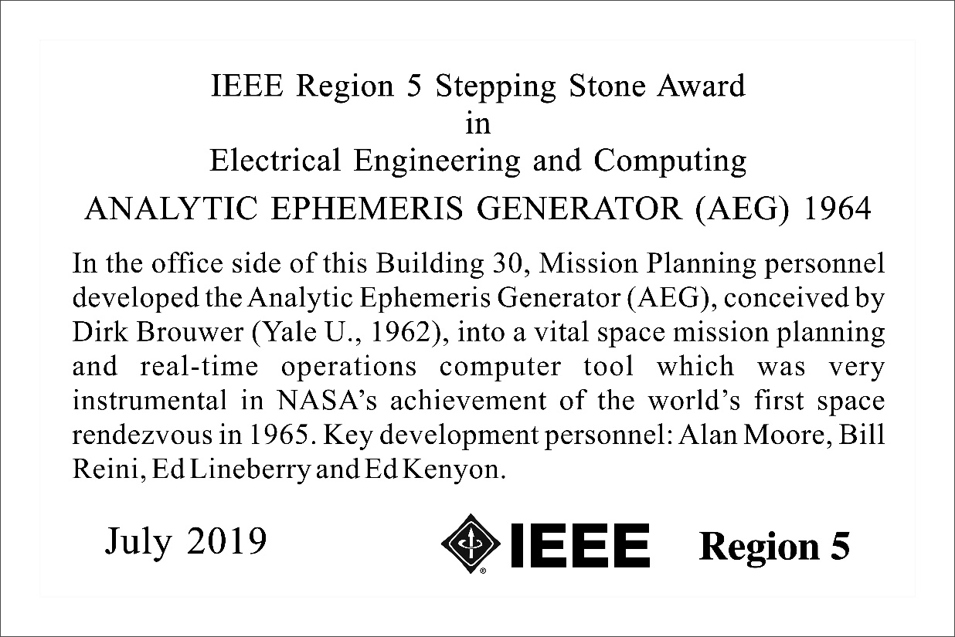

**The AEG Stepping Stone award plaque permanently displayed in Mission Control Building in Johnson Space Center.**

Another stepping stone award was presented to the Electronic Systems Test Laboratory (ESTL). NASA and the Johnson Space Center was recognized for the development of the Electronic Systems Test Laboratory (ESTL) which supported the complexities of an entirely new communications technique – a unified voice / data carrier. Subsequent system configurations are currently providing the testing for newer technical advances in communication techniques.

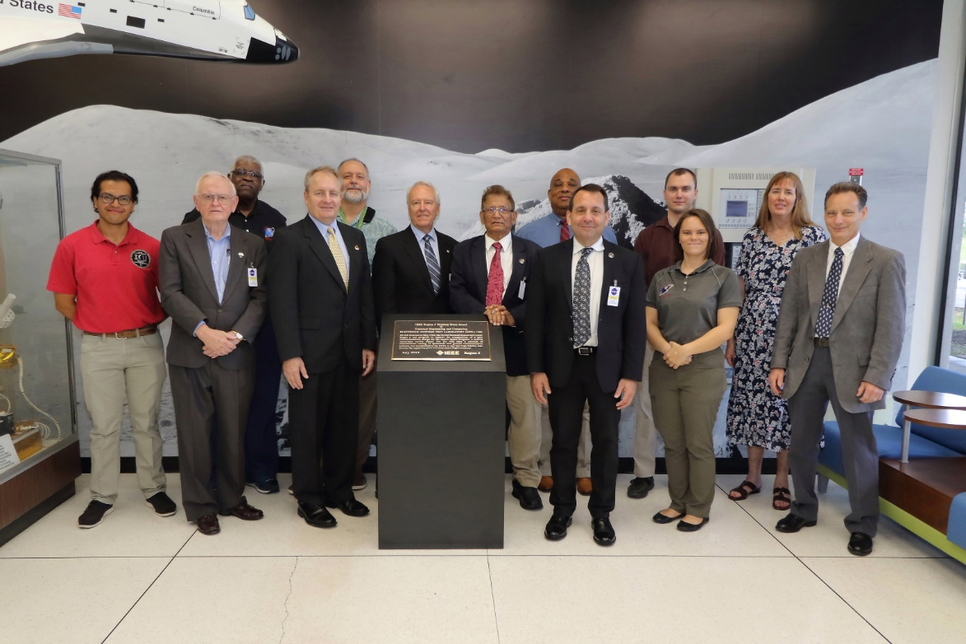

**The ESTL team, and IEEE dignitaries.**

**The ESTL Stepping Stone award plaque permanently displayed in Johnson Space Center**

The IEEE Region 5 [Stepping Stone Award](http://ieeer5.org/awards/stepping-stone-award/) in the IEEE Fields of Interest honors significant technical achievements in these fields. Stepping Stones recognize technological innovation and excellence for the benefit of humanity found in unique products, services, seminal papers, and patents. An achievement must have importance to the technologies associated with Region 5 in order to be proposed as a Stepping Stone—e.g. invented, initially demonstrated, first used, produced in Region 5.

Stepping Stones honor the achievement, rather than necessarily a place or a person. Stepping Stones may be proposed by any Region 5 IEEE member.

[IEEE TryEngineering Summer Institute TAMU](https://r5.ieee.org/houston/ieee-tryengineering-summer-institute-tamu/)

by [James Epkins](https://www.linkedin.com/in/james-epkins-jr-8232195a/)

On Friday, July 26, 2019 [IEEE TryEngineering Summer Institute South](https://tryengineering.org/student/ieee-tryengineering-summer-institute-texas-am-university/) location at [Texas A&M University](http://www.tamu.edu/) hosted over 300 students from around the world. At the TryEngineering Summer Institute (TESI) program, 8th – 12th grade school students explored various engineering fields, such as Electronics, Electrical, Civil, Mechanical, and Aerospace. The TESI program also facilitated an opportunity for students to meet working engineers and experience VIP tours of engineering companies and centers. These activities include an a behind-the-scenes tour at the [NASA Johnson Space Center](https://www.nasa.gov/centers/johnson/home/index.html), a tour of the physical plant that supplies power to the [City of College Station](https://www.cstx.gov/), bowling on State-of-the-art bowling lanes for fun, and much more. The students get experience dorm life and local attractions at College Station during the two-weeks per session.

The highlight of the program had to be the panel sessions with today’s STEM professionals. IEEE R5 [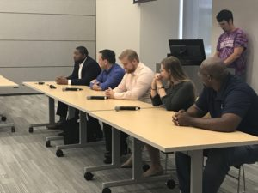](https://r5.ieee.org/houston/wp-content/uploads/sites/32/2019/08/IMG_2937.jpg)Director [Bob Shapiro](https://www.linkedin.com/in/rcshapiro/), is a Land Mobile Radio Consultant with **RCS Wireless Consulting**; Ft.Worth Section member [Derrick Webster](https://www.linkedin.com/in/derrick-webster-b2255823/), is an Electricity Delivery Associate at [**Oncor Energy**](https://www.oncor.com/EN/Pages/default.html); [Lamar University](https://www.lamar.edu/) Student Branch member [James Epkins](https://www.linkedin.com/in/james-epkins-jr-8232195a/), IEEE Student Branch Young Professional;  Houston Section member [Sean White](https://www.linkedin.com/in/sean-j-white/) EIT, is an Assistant Instrument & Controls Engineer at [**Burns & McDonnell**](https://www.burnsmcd.com/); and Houston Section member [Moriah Hargrove Anders](https://www.linkedin.com/in/moriah-hargrove-anders-30926751/), is a Patent Agent at [**Fletcher Yoder Law Firm**](https://www.fyiplaw.com/)**;** and the panel discussion was co-facilitated by R5 South Area Chair [Christopher Sanderson](https://www.linkedin.com/in/christophersanderson/), Account Manager with [**HV Sales Company, Inc.**](http://www.hvsales.com/)

During this time the panelists spoke on their individual experiences as students and now professionals in their engineering fields. Questions from the TESI students ranged from ***why did you choose your STEM field in Engineering?*** To ***what were some of the obstacles you experienced?***

[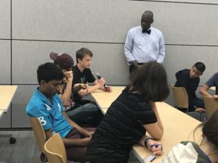](https://r5.ieee.org/houston/wp-content/uploads/sites/32/2019/08/IMG_0793.jpg)The panel shared a variety of experiences on why they chose engineering as a profession, ***why they chose their college?*** To ***how much they enjoy their profession?*** They were truthful and passionate with their experiences. You could see that these panelists wanted to share with these students not just choose STEM as a profession but to make the right choices in their personal lives along the way. There was a fountain of advice given about classes, study habits, workplace culture, and placing the right people around you. As you can imagine these were interesting and engaging questions. It was a great opportunity for these young future professionals to see how broad the field STEM is and how STEM majors come from all different walks of life and the diverse opportunities available. The TESI program give the opportunity to show how engineering can make a difference in the way our world can work better together. Students can get a taste of engineering before college, alongside their peers from other schools from around the world. It is also a great chance for educators to learn how to tailor their lesson plans to increase their student’s interest in engineering and technology careers.

[Call for IEEE-USA Awards Nominations](https://r5.ieee.org/houston/call-for-ieee-usa-awards/) – by [Vincent Palughi](mailto:vpalughi@ieee.org)

[[](https://r5.ieee.org/houston/wp-content/uploads/sites/32/2015/10/IEEE-USA.jpeg)](https://r5.ieee.org/houston/wp-content/uploads/sites/32/2015/10/IEEE-USA.jpeg)

[**IEEE-USA Awards – Submit Your Nominations Today!**](https://ieeeusa.org/volunteers/awards-recognition/)

Every year, the prestigious IEEE-USA Awards recognize excellence in professionalism, technical achievement, and literary contributions to public awareness and understanding of the engineering profession in the United States. If you know someone deserving, nominate them today! The submission deadline is 15 September**.**

Visit: <https://ieeeusa.org/volunteers/awards-recognition/>

IEEEXtreme 13.0 Registration Opens on 5th August 2019

By [Christopher Sanderson](https://www.linkedin.com/in/christophersanderson/)

Registration for IEEEXtreme 13.0 will open on 5 August 2019.  **The competition will take place on 19 October 2019.** Please refer to our website [www.ieeextreme.org](https://ieeextreme.org/) for all current information. IEEEXtreme is a global challenge in which teams of IEEE Student members – advised and proctored by an IEEE member, and often supported by an IEEE Student Branch – compete in a 24-hour time span against each other to solve a set of programming problems.

[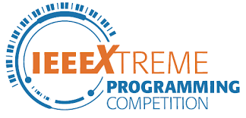](https://r5.ieee.org/houston/wp-content/uploads/sites/32/2018/11/IEEEXtreme-logo2.png)

About IEEExTreme

[IEEEXtreme was created](https://en.wikipedia.org/wiki/IEEEXtreme) in 2006 by Marko Delimar and Ricardo Varela who, at the time, were with the IEEE Student Activities Committee. The first IEEEXtreme 1.0 competition was held in 2006 with a global participation of 44 teams and 150 contestants. The numbers more than tripled the second time it was held, in 2008, to 130 teams with 500 participants. The iteration of IEEEXtreme 9.0 in 2015, enjoyed the registration of over 2,300 teams, and participation of over 1,900 teams, 5,500+ student competitors, 600+ proctors, and 100+ volunteers around the world.

[Are you Eligible?](https://ieeextreme.org/eligibility/)

* All participants must be **IEEE members *(Student member or Graduate Student member only)*** to register and compete in the competition. IEEE membership numbers are required.
* Participants must compete as part of a team of **up to three IEEE Student or Graduate Student members. Teams should only include a maximum of two Graduate Student members per team.**
* **Universities and colleges can have multiple teams.**
* Each team must have a **proctor to supervise during the 24-hour programming competition.**
* **Team members must solve and complete the problems without assistance from others.**

Please note that the intent and spirit of the competition is for the students, not others, to solve a problem. People acting as proctor must limit the level of support and must not contribute in any other form that might be considered original authorship, or in any way that may enable claims of rights or ownership to the submitted entries. In no case will work on behalf of teams or individuals be allowed.

Lunchtime Downtown IEEE Meeting with the Control Systems Society by [Vincent Palughi](mailto:vpalughi@ieee.org)

[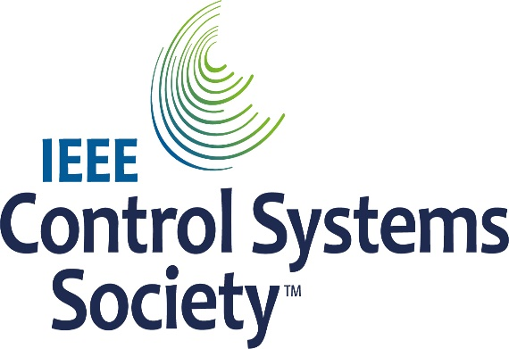](http://ieeecss.org/)

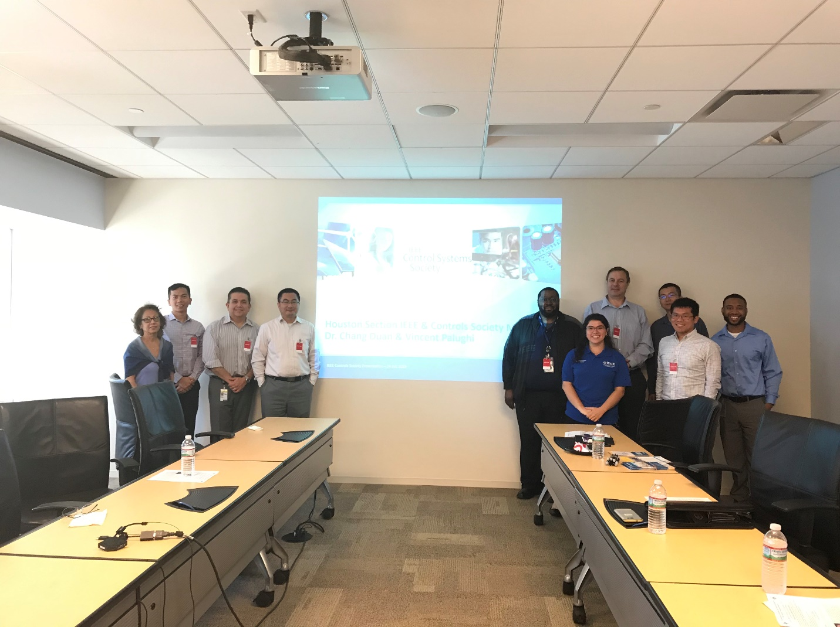

**Controls System Society Meeting Attendees 24JUL2019**.

On July 24th the Houston section [IEEE Control Systems Society](http://ieeecss.org/) held a meeting at Chevron’s downtown office. Several IEEE members working downtown attended, as well as a few who drove in. Chairman [Dr. Chang Duan](mailto:chang.duan@gmail.com) presented an introduction to the Control Systems Society and reviewed some of the many resources available on the website. [Vincent Palughi](mailto:vpalughi@ieee.org) with the IEEE Houston Section News and Publicity team provided some information on upcoming events in the local section.

We hope to encourage a rotating monthly meeting, at various IEEE employers’ locations in the downtown area to supplement the regular IEEE meetings, expose IEEE members who work downtown to various IEEE societies, and to create networking opportunities. If anyone is interested in hosting the next downtown lunch meeting, please contact [Vincent Palughi](mailto:vpalughi@ieee.org).

[[](http://sites.ieee.org/houston/events/2019-05/)Houston Section Events for 2019](https://r5.ieee.org/houston/events/)

Check out the Houston Section Events page for all the latest information taking place in the Greater Houston Metro Area. Looking forward to seeing you at an event soon.

*The Pocket Scope* is the monthly newsletter of the [Houston Section](https://r5.ieee.org/houston/) of the [Institute of Electrical and Electronic Engineers, Inc.](http://www.ieee.org/) New issues are published around the 15th of each month. The deadline for inclusion of material is the 10th of the month. Send submissions, comments, or questions to [Vincent Palughi](mailto:vpalughi@ieee.org) or [Fabian Pineda](mailto:fabianpineda@ieee.org)Accept & Close

* [Home](https://r5.ieee.org/houston/)
* [Contact IEEE Houston Section](http://r5.ieee.org/houston/contact-us/)
* [Accessibility](http://www.ieee.org/accessibility_statement.html)
* [Privacy & Opting Out of Cookies](http://www.ieee.org/security_privacy.html)
* [Nondiscrimination Policy](http://www.ieee.org/about/corporate/governance/p9-26.html)

IEEE Houston Section  
Houston Section  
© Copyright 2019 IEEE - All rights reserved. Use of this Web site signifies your agreement to the [IEEE Terms and Conditions](http://www.ieee.org/site_terms_conditions.html).  
A not-for-profit organization, IEEE is the world's largest technical professional organization dedicated to advancing technology for the benefit of humanity.

|  |  |
| --- | --- |
|  |  |

|  |  |
| --- | --- |
|  |  |